Henfield Parish Council

Business Plan (BP)

2022-2025

Welcome to Henfield Parish Council’s business plan. This sets out key actions and activities to be completed in the period up to the financial year ending March 2025 and should provide an understanding of the priorities for the Council in this period.

The 3 Year Business Plan sets out the areas additional to day-to-day operations, on which the Council proposes to focus for the ongoing benefit of the community. It will be subject to regular review and monitoring.

January 2022
Introduction and Overview

This Business Plan should be read in conjunction with HPC’s Strategic Plan Priorities, Infrastructure Delivery Plan and Annual Financial Plan.

Funding for Parish Council activity comes from two principal sources
the Precept derived from individual household contributions as part of the council tax collection process and the funds generated by housing development through Community Infrastructure Levy (CIL). The Precept is set by the Parish Council annually; the funds from housing are one-off contributions that are paid when conditions outlined in a legal agreement are reached, normally at the completion of certain phases of the development. By their very nature, CIL funds are wholly dependent on the timing of any development which is beyond control of the Parish Council.

In general terms, the precept is used to:
- fulfil our statutory obligations
- support and sustain the Parish Office, staffing and running costs
- maintain the facilities and infrastructure within the village and surrounding countryside
- manage and improve the ‘look and feel’ of Henfield
- support local community organisations
- attract people into Henfield to support the local economy

Larger one-off funds generated by housing development are utilised for major projects which are defined as priorities by our Councillors in consultation with the community (e.g. the building of the Link Road from Deer Park to the Leisure Centre, restoration of the Memorial Field as a playing field). The sporadic nature of major funding being available means it is difficult to plan, in financial years, which projects can be undertaken but the Infrastructure Delivery Plan lists those major projects that are a priority for HPC and is attached in Appendix 1 of this Business Plan with the caveat that only some of these projects are likely to be funded and completed during the 3 year term of the Business Plan.

The format of this Plan does not seek to list everything the Parish Council does as a matter of routine but highlights key actions that could support one of the 7 aims in the Strategic Plan. There are some actions that are sufficiently material to be included in a business plan.

Strategic Plan (SP) Headlines

Without reporting all of its detail as a point of reference for the Business Plan it is worthwhile recording the main priorities of the Strategic Plan (SP).

The SP identifies the following 7 aims which are designed to promote and enable the health and wellbeing of our residents, businesses and the parish as a whole community. The strategy can be best described as one of working to the principles of "Protecting, Maintaining and Improving” what we do under each of these aims.

- Ensure that development and growth is appropriate for a rural community.

- Retain a vibrant and successful High Street and create a positive environment for local businesses to thrive.

- Nurture and encourage the wellbeing of our clubs, societies and organisations which are the foundation of our strong community spirit.

- Support social and cultural activities which bring together residents and visitors and encourage the sense of community to flourish.

- Build our Visitor Economy by attracting people to explore our countryside and history.

- Support initiatives which help those in the community that need it most.

- Promote activities which protect our environment and encourage biodiversity.

Business Plan actions planned against each of the Strategic Plan Priorities

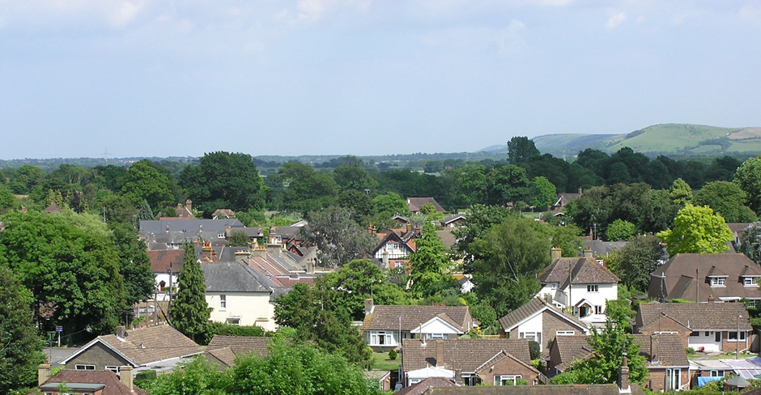

1. Ensure that development and growth is appropriate for a rural community

We recognise that further housing development is required to sustain general economic development and to fulfil our obligations to our District Council. One objective of this BP is our commitment to ensure that new homes are located most appropriately, as defined in our Neighbourhood Plan and the Horsham Local Plan and that they are constructed in harmony with their setting making a positive contribution to the local environment, as defined in the Parish Design Statement. By inference whilst we are not the decision making body on planning issues we also commit to pushing back on inappropriate development to preserve the rural character of the parish and the setting of our village. Henfield Parish Council’s Plans Advisory Committee (PAC) takes the lead in planning related matters and interested residents are encouraged to attend.

We also realise the value that can be added by attracting inward investment in our infrastructure that new development can bring through the generation CIL monies for major projects. These major projects are defined in our Infrastructure Delivery Plan (IDP) and the intention is that the community will fund and deliver these priorities. Henfield Parish Council will contribute by setting aside a portion of precept funds (provisions) each year to be held in Parish Council reserves/contribution which can then be released when sufficient Community Fund Raising/ Grants/ and CIL funds are available. In the case of priorities involving assets which are owned by other community organisations reserves funds will be made available once that organisations portion of funding has been raised so that the project is delivered through a funding partnership between community organisations, the Parish Council and CIL funding. Our IDP has two sections. The blue section lists the major projects, the pink section lists the smaller cost projects which we would expect to be able to support using precept and reserve funding from within the parish.

Specific actions planned during the life of this Business Plan are:

- Deliver, influence and gain acceptance of the Neighbourhood Plan including sites allocated in the Horsham Local Plan ensuring that we are “on track” to deliver 370 new homes by 2038 (an average of 53 new homes per annum over the next 7 years).
- Ensure that design standards in planning applications remain in keeping with their setting and meet the requirements of the Horsham District Planning Framework and Henfield’s Parish Design Statement.
- Minimise ‘outside built up area boundary’ development to retain the rural look and feel of the parish.
- Use the retention of a ‘village look and feel’ as a guiding principle for any permitted development and to positively support applications that protect and improve the look and feel of the village.
- Although not the decision makers, to object to planning applications which are considered inappropriate and to request that the District Council escalate such cases to the appropriate Planning Committee. When it is felt appropriate, we will put our case in person at the Committee and represent community views at Planning Appeals.
- We will monitor and report on the proportion of cases that are ‘approved’ when PAC objects to them.
(We could set ourselves a success target here if we wanted to be bold i.e. we will strive for 75% of cases to which we object to be refused by HDC. We would need to measure that at PAC).
- Make best use of CIL/Reserves to support delivery of the priorities set out in the IDP. Our aim is to deliver our contribute toward the delivery of at least one major project and three smaller projects which improve our infrastructure each year if finances permit.
- Maintain positive relationships with HDC and WSCC and to work with both to deliver on the priorities of our community.
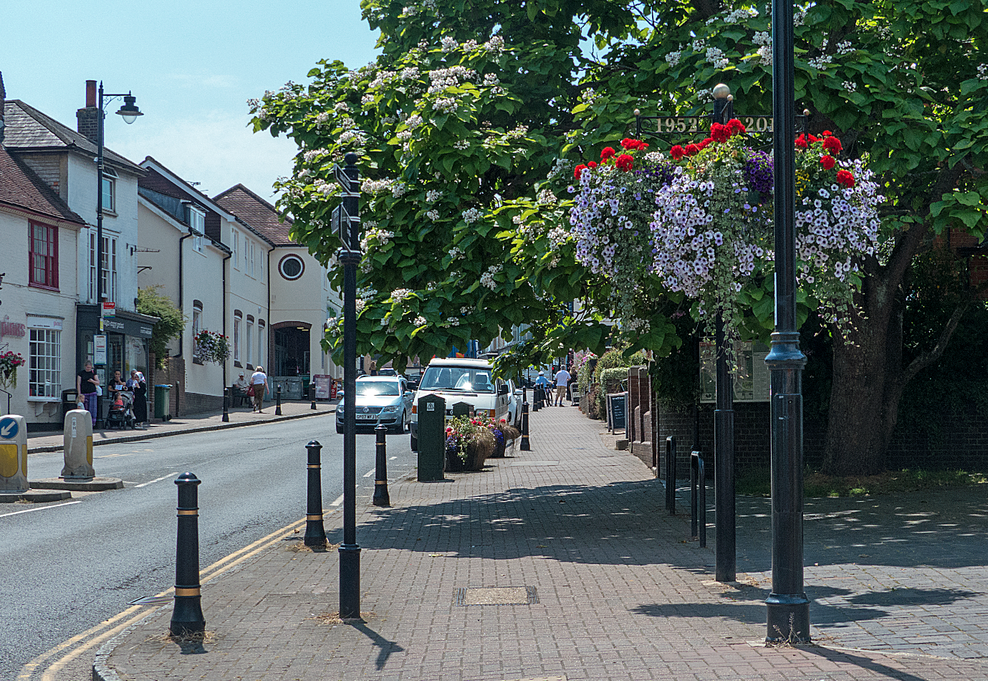

2. Retain a vibrant and successful High Street and create a positive environment for local businesses to thrive.

There is a practical limit to the influence the Parish Council can have on the vibrancy of a high street and to affecting the economic environment for local business. Rents and rates, business subsidies and start-up grants are controlled by commercial landlords, county, district, local and central government and, as such, outside the influence of HPC.

However, through our Village Amenities Committee (VA) we take an active role in ensuring that the areas within our built-up area boundary are maintained and improved, ensuring that the village remains an attractive place to live and visit. Our Works Officers have a key role to play in this work as they do much to maintain and preserve the look and feel of our village.

There are a number of actions that HPC is capable of influencing that may make a positive contribution:

- Attracting visitors to the village by promoting tourism.
- Creating and maintaining an attractive village centre.
- Encouraging residents to “shop local” by making the high street attractive, keeping it clean, installing planters, hanging baskets, Christmas lights etc.
- Being cognisant of the needs of local business when providing advisory planning decisions to Horsham District Council, balancing the importance of business with other interests within the village.
- Providing publicity, marketing and generating interest in local business through our social media platforms.
- Produce a Community Transport Plan by July 2023.

Specific actions during the life of this Business Plan are:

- Encourage initiatives which bring more footfall to the High Street i.e. Monthly Food & Drink Market, Christmas Shopping Events etc.
- Develop and promote a series of walking trails which start and finish in our High Street, “the Henfield Trails” to attract visitors, each promoted with an online and paper leaflet option.
- To create a more attractive ‘village square’ in the area located between the High Street and Bishop Lane and to restore the village clock.
- A Community Transport Plan will seek to support initiatives in the Parish relating to transport, parking and road use
- Our community speed watch team will seek to educate drivers on the importance of our speed limits, we have installed two new portable speed indicators
- Work with Henfield Hall to create a cultural and entertainment centre with visitor space
- Working with Henfield Community Partnership to improve the links between the Parish Council and local business.

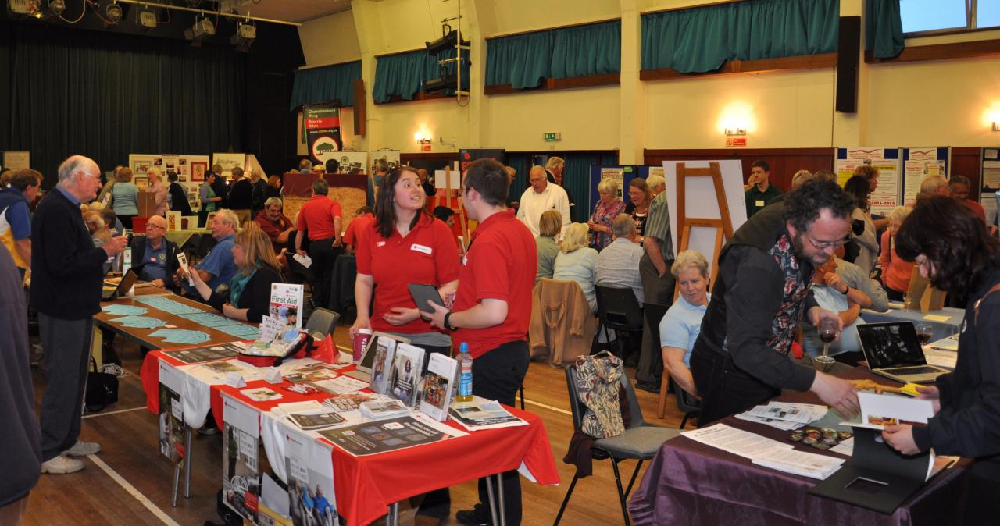

3. Nurture and encourage the wellbeing of the 100+ local clubs, societies and organisations.

Henfield already has a very strong network of clubs, societies and other interest groups/organisations that are organised and run on a voluntary basis. In addition to those that operate within the village there are also many other groups who visit the village and provide valuable services. HPC maintains links with many of these formally or informally and believes it has a role in facilitating engagement, ensuring that the strong sense of community continues to thrive.

In order to further this, HPC commits to:
- Organise periodic events, providing publicity, that give clubs and societies the opportunity to showcase what they represent. This can be done physically and/or virtually.
- Maintain the currency of its annual Community Facilities review so that we ensure that appropriate facilities are provided and understand where improvements are needed.

Specific actions during the life of this Business Plan are:

- At least annually to hold Community Buildings & Facilities Meetings with our Clubs & Societies to understand their challenges and priorities and to explore how the Parish Council might be able to help.
- To work with those organisations with larger scale projects listed in our IDP to ensure that we do all that we can to ensure that they are delivered.
- To work with the owners of our Community Buildings to ensure that they are maintained, improved and are fit for purpose to deliver future needs of the community.
- To promote an understanding of the roles of each of the community organisations, to avoid duplication without stifling competition.
- To provide funding support for capital works through the allocation of CIL funds and Precept Reserves in accordance with the priorities outlined in our IDP.
- Where feasible, to provide advice and support on organisational governance and fundraising.

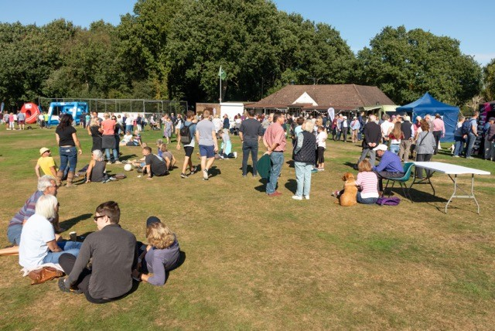

4. Support social and cultural activities which bring together residents and visitors and encourage the sense of community to flourish.

HPC has a long tradition of providing leadership at certain ‘whole village’ events e.g. Summer Fair, Remembrance Day Parade. This role should continue through the provision of organisational leadership, physical presence, insurances, liaison with Henfield Community Partnership, WSCC and HDC as appropriate. In addition to the events traditionally supported we will try to identify other opportunities for new events.
Encouraging the continuation of Henfield as a village community is important to us. To facilitate this we are supportive of activities which seek to bring together the whole community or specific groups within the village.

Specific actions during the life of this Business Plan are:

- Our annual Remembrance Service and Community Parade.
- An annual community walk to encourage residents to enjoy our countryside and raise funding for local charities.
- An annual community event held in one of our open spaces or community buildings, some examples are a Summer Fair, Queens Jubilee Events, Memorial Field celebration.
- To participate in District and County sponsored events such as the Horsham Food Fair, Car Festivals etc.
- To support through participation and practical resources community organisations running community events i.e. Gardens & Arts Festival, Henfield Haven music concerts, quizzes etc.
- Our aim is to help to organise and promote at least three community events each year.

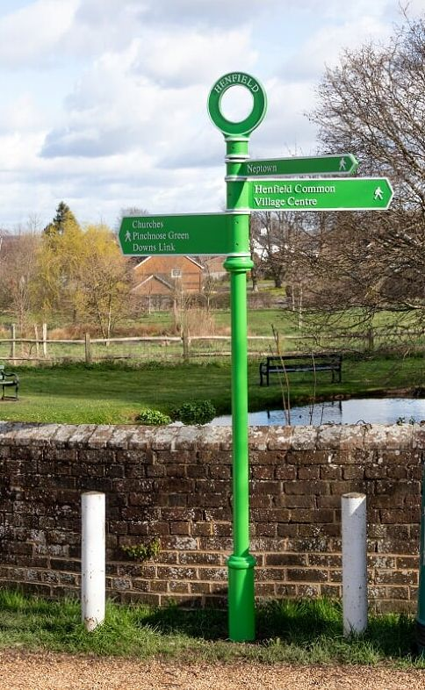

5. Build our Visitor Economy by attracting people to explore our countryside and history

Making our countryside and history more accessible are key objectives of our Recreation & Open Spaces Committee (ROS) and our Museum Committee. Recent initiatives include the development of 6 Henfield trails through our local countryside. The Museum is a key part of showcasing Henfield’s history and, during the pandemic, much has been done to make online access available to the resources held by the Museum. Making access to resource available digitally, so that awareness of opportunity is built will continue to be a priority for 2022-2025.

Specific actions during the life of this Business Plan are:

- To use our Social Media platforms to promote village events, activities and visitor attractions at every available opportunity.
- We plan to design and deliver two Henfield Trails each year during the Business Plan providing six opportunities to explore the village and countryside in total. Ensuring that these are well signed and maintained including a six-monthly inspection is a key part of our work.
- To actively encourage Henfield Museum to reach a wider audience.
- To support the Joint Commons Committee in promoting conservation and enjoyment of Henfield’s commons.

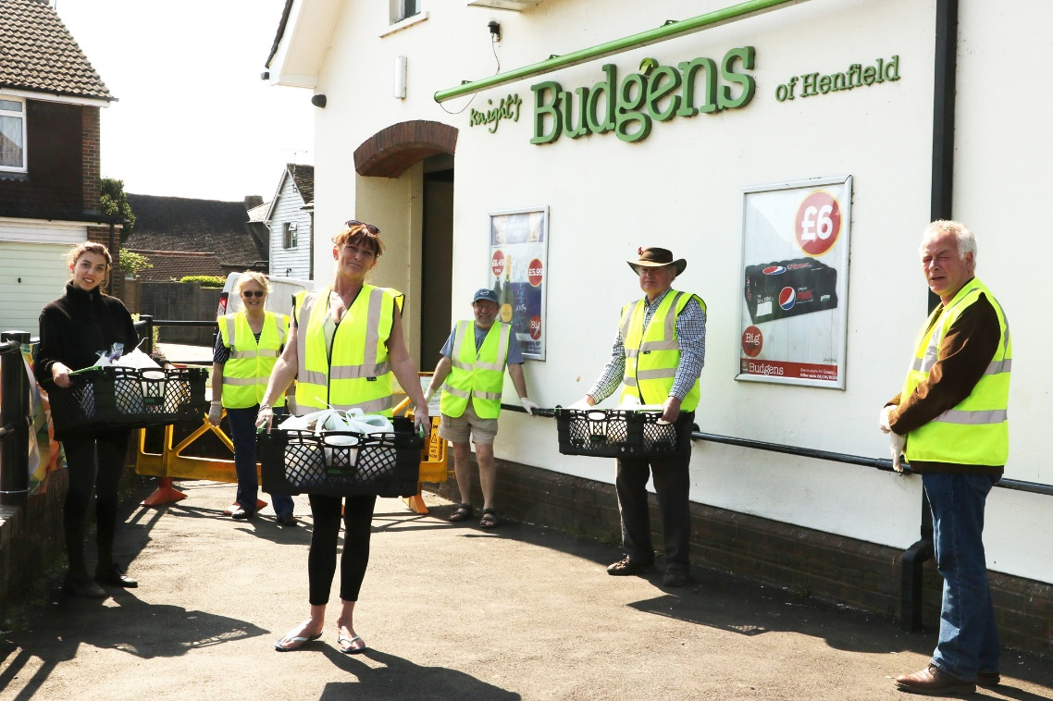

6. Support initiatives which help those in the community that need it most.

A great example of this during the peak of the pandemic was the establishment of the Henfield Helpline which fielded calls from the vulnerable, provided practical assistance through a food shopping and prescription medication delivery services. This was very well received and promoted a strong sense of community. HPC partnered extremely productively with The Haven, and the Henfield Medical Centre each bringing their own knowledge and expertise.

Some sections of society are potentially better catered for than others and it is HPC’s role to ensure that all segments are well supported. It has been identified that there is more that could be done to engage the current generation of teenagers (over and above what the Youth Club does well). As such, HPC commit to:

Specific actions during the life of this Business Plan are:

- To continue to support initiatives which help the frail and vulnerable in our community, acknowledging the importance of the Henfield Medical Centre, Henfield Haven and Henfield Youth Club ensuring that they receive the support the require be that physical, financial or promotion.
- To develop a better engagement with young people in the community, the first step being the establishment of a Youth Officer role which will explore how to improve our understanding of their needs.
- To construct plans and deliver improvements in the services that young people need.
- To ensure that those with challenges, be they mental health, isolation, or physical impairments, are properly considered in all that we do.
- Have a sub-committee of HPC that looks solely at the interests of the youth in our society.
- Employ a paid member of the Parish Office staff as a ‘Youth Officer.’
- Build a plan for how best to engage this segment of the Henfield community.
- Designate 2023 as the Henfield Year of Young People.

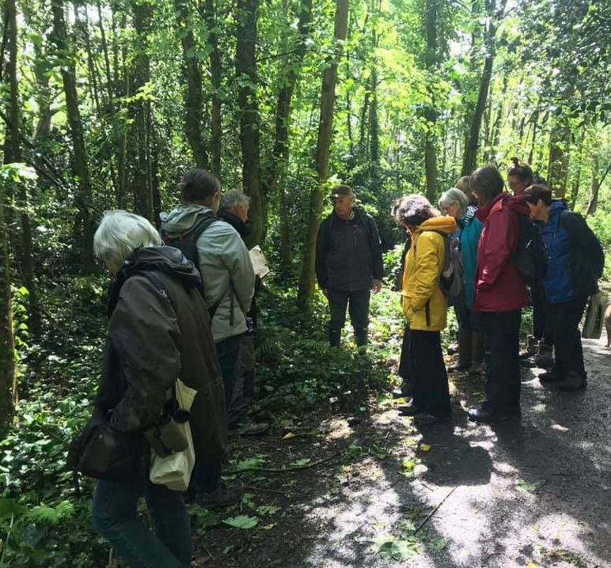

7. Promote activities which protect our environment

HPC is committed to providing a profound influence on the pressing need to address climate-related agenda and is very alert to environmental issues. It is very supportive of Sustainable Henfield 2030 but does not seek to duplicate effort. Actions identified for HPC to pursue are:
- Deliver the actions contained in the HPC Carbon Reduction Plan
- Publicise the trails and ‘safe routes’ already developed
- Parish Council to set a target date to become carbon-neutral
- Identify and Plan to close ‘nature gaps’ by planting
- Give priority consideration to the environmental impact in every decision made by HPC.

Specific actions during the life of this Business Plan are:

- Henfield has declared a Climate Emergency which will be central to our activities ensuring that wherever we can our work is sustainable and carbon neutral.
- We have created a specific Biodiversity Group which is focused on our environment and delivering the Carbon Reduction Plan.
- We will seek to create nature corridors around the Parish
- We will seek to involve and inform the community through Social Media to help our residents understand and explain what they can do to support Sustainability and Biodiversity.
- Through our Safe Routes Group we will work with the community to ensure that we develop cycling, horse riding and walking routes which avoid busy main roads and encourage people to avoid the use of cars for travel within the parish.
- The Parish Council will set a target to become carbon neutral in all our activities. In support of this we will install double glazing and work with the Henfield Hall to ensure solar panels to make us more energy efficient.
- Deliver a Habitat Survey of the Parish to inform future decision making.
- Designate 2024 as the Henfield Year of Bio Diversity.

Actions arising from the process of running HPC

There are a small number of actions that form part of this business plan derived from the way in which the Parish Council is managed and run. These are categorised under a limited number of headings.

Diversity and succession

HPC seeks to be representative of the community it represents (noting that the process by which Councillor roles are filled are either by election or co-option). It is important that HPC is well led with a range of skills in the team of 15 parish councillors. As such, in the coming period, HPC commits to:
- Ensure that Parish Council roles are well advertised
- HPC publicises experience of what it is like to be a Councillor
- When seeking co-opted candidates, HPC will give active consideration to the skills mix, as well as all other factors that might ensure a fully diverse range of candidates is considered to ensure a diverse and representative Parish Council.
- Its Parish Councillors being visible and accessible
- The Parish Council as a whole has sufficient strength and depth to ensure it is well led in the future
- Parish Office staffing is given priority to ensure internal succession possibilities are balanced

Building awareness through publicity and transparency

Meetings of the Parish Council and the sub-committees are all open to the public and they are able to participate, at least in part. The pandemic has brought about a different means of communication by necessity and members of the public have been able to join the meetings by Zoom as well as meetings starting to be streamed using Facebook. This has potentially increased awareness and participation. As we return to meetings being face-to-face, engagement could be continued by:
- Streaming meetings
- Encouraging members of the public to engage in person
- Publicising in BN5 and the Parish Magazine, the work of HPC and the decisions made/to be made.

Parish Council Committee Meeting Details

- Parish Council Meeting - 7pm first Tuesday of each month (except August), Henfield Hall Garden Room. Meetings are lived streamed on Facebook.
- Finance, Risk & Change Committee (FRC) - 7pm third Tuesday of each month, Henfield Hall Garden Room.
- Village Amenities (VA) – 9:30am second Wednesday (bi-monthly), Henfield Hall, Garden Room.
- Recreation & Open Spaces (ROS) – 9:30am second Wednesday (bi-monthly), Henfield Hall, Garden Room.
- Joint Commons Committee (JCC) – bi-monthly.
- Museum Committee – 7:30pm fourth Wednesday (quarterly).
Appendix 1

Look-up table of actions:

- Actions within the remit of Henfield Parish Council.
- Actions dependant on external funding.
- Actions dependant on the activities of other community organisations.

Appendix 2

- The Infrastructure Delivery Plans

