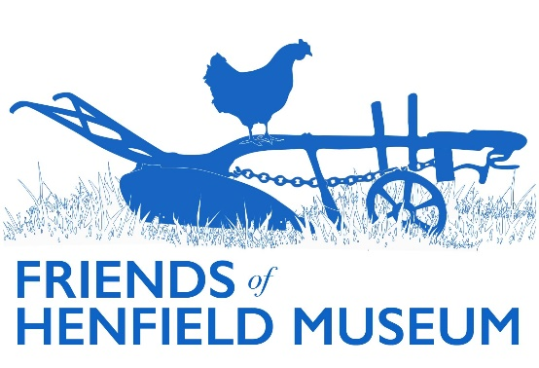

Friends Update

*May 2025*

*General*

* Membership: current post-AGM membership TBC. We currently have 90 paid up memberships from the 2024 year (with ~36 not yet renewed this year as of 6th May), including a mixture of individual (£10) and family (£15, two people) and 7 life. This equates to 124 Friends total. Per AGM vote, there will be a new simplified single membership fee of £10 per person from 2026 onwards, with family memberships removed.
* Merchandise: ‘Haunted Henfield’ reprinted and now on sale again for £10. DVDs ‘Henfield at War’ (£7) and ‘Henfield’s Wonderful Railway’ (£5) also both on sale.
* Website: content updated in ‘Those Who Served’ (Marjorie Baker collection). Current/Past display pages updated. Additional accessibility info added to the ‘Contact Us page. Wording added/emphasised to state that members of the public can enquire after objects in the collection. Blog articles (in aggregate) continue to be the most popular area. View full [website analytics](https://docs.google.com/spreadsheets/d/1jLW4bBTGbHKTo2nUY-BAVvnbVkyDn_LA/edit?usp=sharing&ouid=104915441849188783759&rtpof=true&sd=true).

**Analytics - Website & Social Media**

**2024:**

* + Approximately 5000 visits to the website – of which 3515 were ‘engaged users’ (two or more screens viewed or 10+seconds on the site)
  + 1150 of those users were from outside the UK
  + About 2/3 of those users found the site organically via search engines, the rest coming either directly or being referred from social media or other sources
  + 1m 42s average (mean) time spent on the site overall (so including very short and very long visits)
  + 11109 total page views
  + Of these the blog articles were the most popular with 3119 views

**Google Business Profile** (the side/infobar you see when searching for the museum via Google): 844 interactions (80% via Google Maps, 20% via Google Search).

**Social media**

* **Facebook**

1100 page followers

1928 direct visits to page

24844 unique users saw content from the page

2947 direct interactions with posts from the page

* **Instagram**

139 page followers

152 unique users reached in 90 days up to 22 February 2025

* **Twitter/X**

207 page followers (other stats no longer available on free accounts).

* Social media: releasing more Marjorie Baker 'Those Who Served' military portraits for VE/VJ 80 on socials/website. Other posts included ‘Jack in the Green’ and Horton Hall area photos, ABC costume display and Uni Brighton costume visit, colourised Easter trugs, 3D scans.
* Roving Display Case: just moved from long stint in Henfield Hall foyer to Free Church. Some photos in the existing WW2 display updated to commemorate VE/VJ 80.
* WSCC Experience Sussex: museum added: <https://www.experiencesussex.com/listing/henfield-museum/257136101/>

Additional comprehensive accessibility questionnaire could be completed should someone wish to.

* St. Peter’s church displays: VE/VJ display with museum content recorded for addition to ‘Past Exhibitions’ section of the website. Pamela Chaston also sent photos of 2016 QEII 90th birthday display also featuring museum content - to be added to 'Royal Celebrations' page.

*Events*

* Spring visit: two successful and most interesting visits to St. Hugh's Charterhouse Carthusian monastery carried out by male members. Hope to present photos/thoughts to female and other members who could not attend.
* Common Fair: joint Friends/History group/museum gazebo with quoit pitch booked.
* AGM: interesting talk by Stewart Angell on WW2 Sussex auxiliary units (the ‘stay-behinds’). Committee continuing as currently minus Maureen Lucas who stands down. Constitutional prohibition on 3-year consecutive limit on terms voted waived to enable Chairman’s continuation.

*Research*

* Glasby drawings: further to previous update, postal package containing some recent photos of the Peachtree church stained glass now received for accession. Polly hopes to continue pursuing what happened to the large 1976 cartoon donation from Henfield to the Atlanta Historical Society.
* Enquiries: re. various local houses, responded to by Alan and myself with historical, photo/map data.

*Projects*

* 3D scanning project: four objects (Neolithic Laurel Leaf spearhead, Bronze Age Palstave axehead, Wilberforce Waistcoat and Medieval Steelyard weight) now [uploaded to Sketchfab](https://sketchfab.com/henfieldmuseum) and receiving decent views (from 67-186). Also linked from the museum website. Romano-German ring scan done, but currently too large to upload to our free account.
* Oral Histories: Reg Saunders oral histories recordings (5 files) done by Steve Bailey/Henfield Haven in 2013 now added with his approval to museum GDrive archive. They await burning to disc and physical accession along with a few others. Volunteers remain needed for both interviewing but also editing snippets.
* Borrer Transcription project:
* Digitisation: bulk of Stage 2 (the in-museum bit) done. Awaiting current cost before further non-framed pictures dispatched for scanning at Max Comms facility. Planned for April 2025 when PC funding available (in combination with Friends funding half).
* Memory box: created during previous Horsham scheme and received from Mike Dixon should we wish to use it. Could be permanently advertised on website in the vein of increasing collection accessibility. These are generally aimed at patients with dementia and allow tactile handling and (hopefully) triggering of memories (the museum has done so ad hoc at the Haven and Red Oaks previously). Horsham Curator contacted; hope to link up with their two scheme volunteers for any tips or info on uptake etc. The box itself currently contains an assortment of new and old objects. As not from the collection, they can be safely handled. To make them Henfield relevant, copies of local photos could be added which relate to objects within (motors and car for toy car, photo of costume/local fashion for sewing pattern book, photo of local industry for tool, etc).